Phase 1:
Phase one testing is intertwined with the testing of the other phases because it makes the base that everything else is built upon. We have included test cases here for deleting tasks, garbage collection, and a deadlock. Below, tasks 2 and 3 are being killed from the user console, display that they are dying, and the log windows shows the same. The first task continues to run without need to yield to the other dead tasks aside from our UI process that controls input. You can see in the process table dump that the tasks are dead and when the screenshot was taken the task 1 was running while the UI thread is waiting.

Testing killing tasks
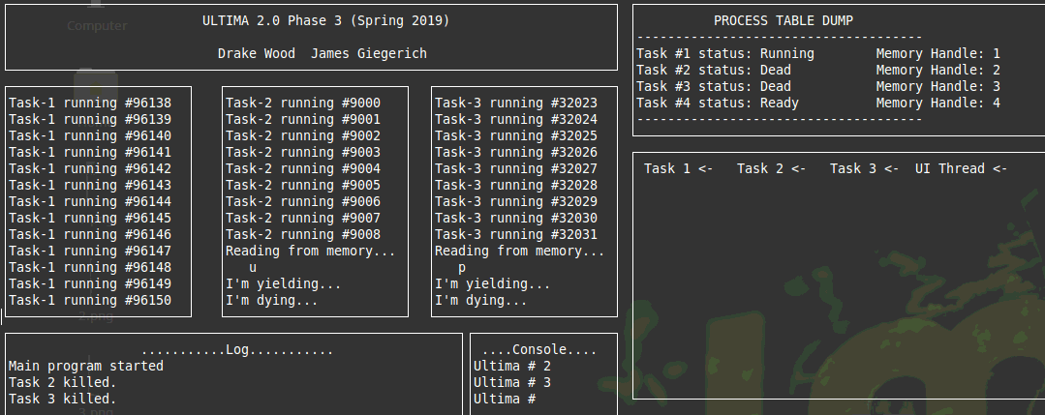

After the tasks are killed garbage collect is called which removes the dead threads from the process table. You can see that they are no longer included and only 3 and 4 remain (1 and 2 were killed this time) as well as the queue printout in the window below that.

Garbage collect
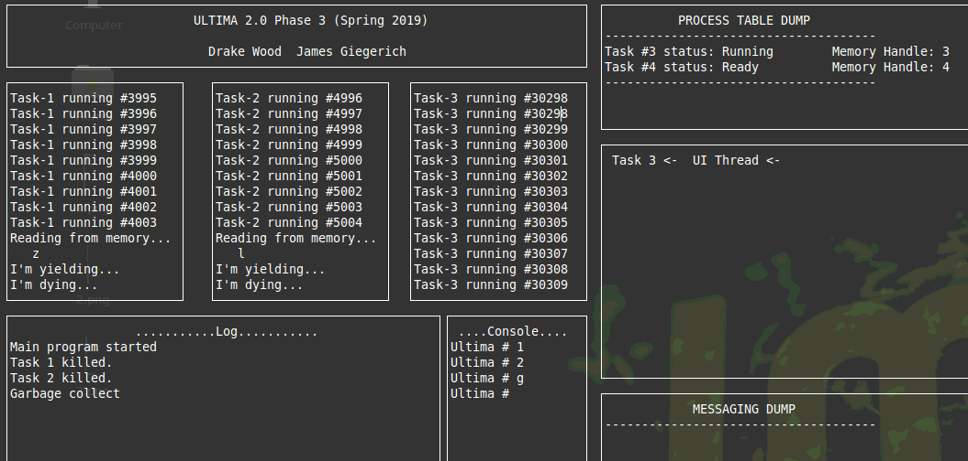

Calling r activates a semaphore that never does any up, calling it twice from the UI thread causes a deadlock where nothing can run. This doesn’t work as intended because we were not aware of an issue in the down function which does not allow the scheduler to continue past the current task if it were to become blocked like this situation.

Deadlock
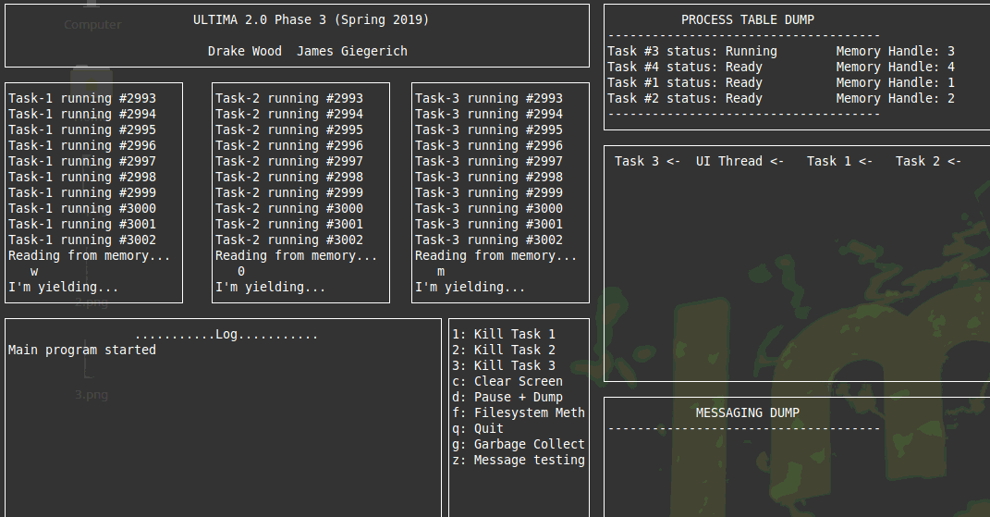

Phase 2:
This phase added message boxes for each task. Upon task creation each task sends messages to the other ones. Our test function prints the contents of the mailbox for task 1, and then displays how many messages there are in that box. Next it displays how many messages are in all boxes. After deleting everything that is in box 1 it displays the number of messages in box 1 and then all boxes again showing that they were deleted.
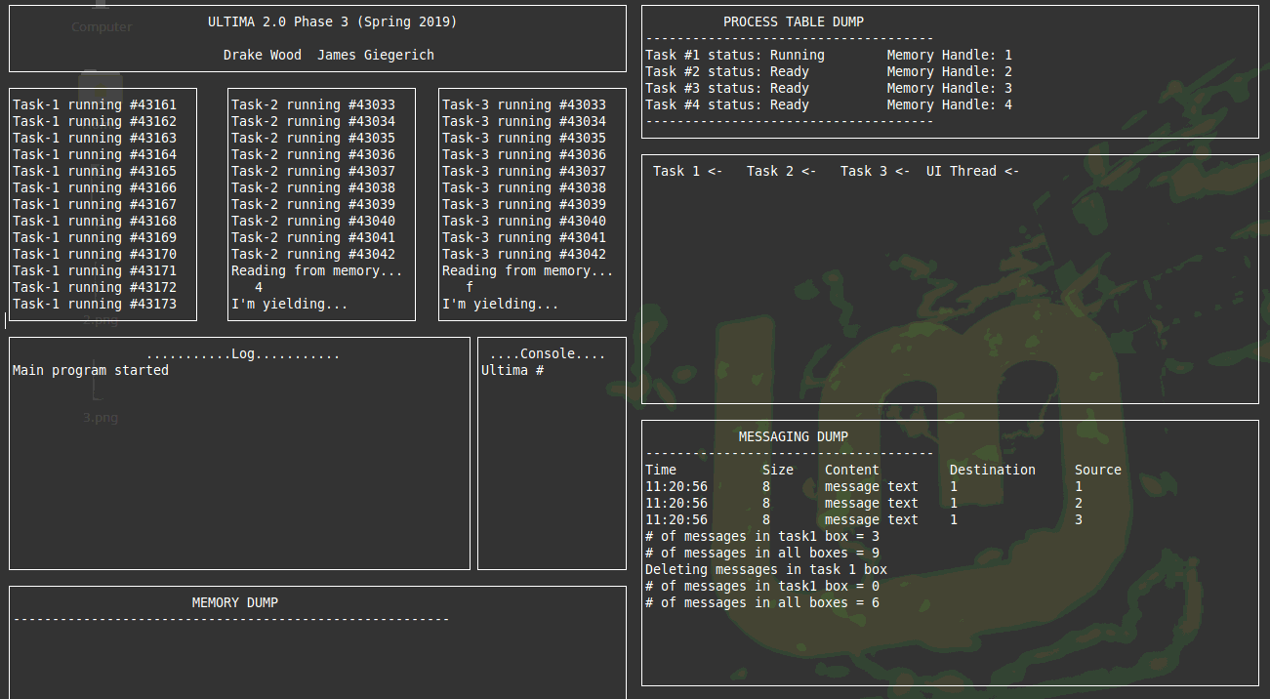

Phase 3:
Here we call a test function to demonstrate the memory management that was implemented in phase 3. First the core is dumped and the memory information for largest, smallest and left is displayed. After that the memory usage function displays the blocks which are used and free. Here we see that all 4 threads are using 1 block and there is 512/1024 space in a free block at the end.
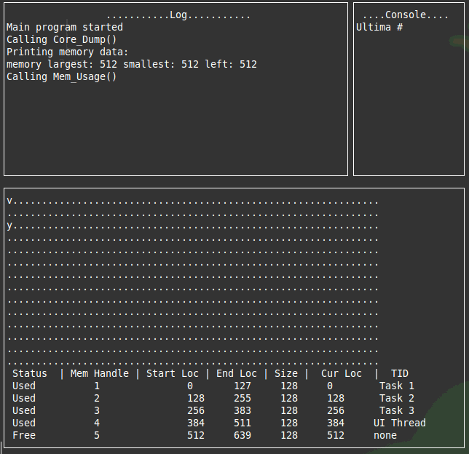

Next we call the overloaded memwrite function which adds a string to the middle of the memory core and then it is displayed with another core dump. We developed an issue with the output of the core at this point and it shows some corrupt characters at the beginning. This isn’t present in the actual memory and just effects the output.
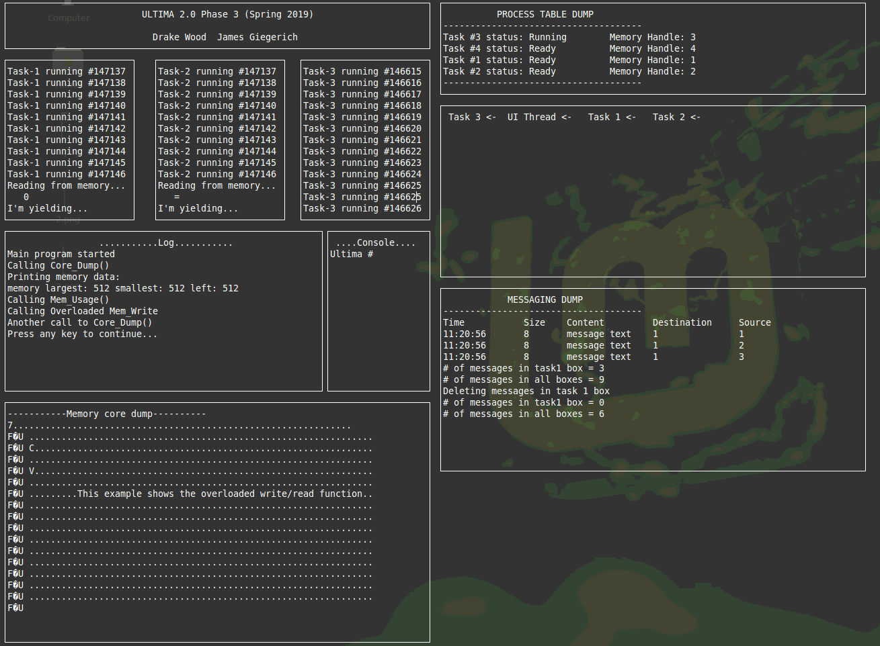

The next output is shown after tasks 1 and 2 have been killed, the memory for them has been freed but it has not been coalesced. Freeing the memory writes #’s to the contents.
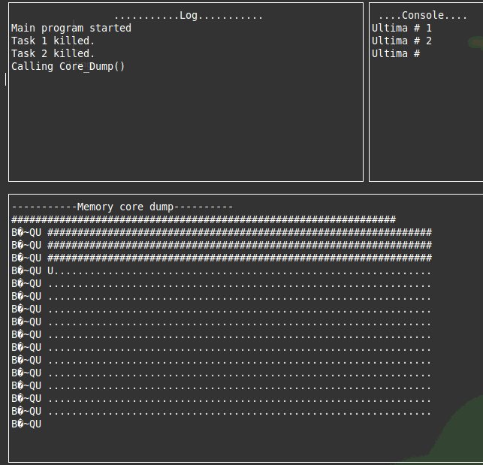

This output window calls the usage function to show that the free blocks are actually free but they are individual holes, not one larger free section of memory, the blocks for 3 and 4 are still intact.
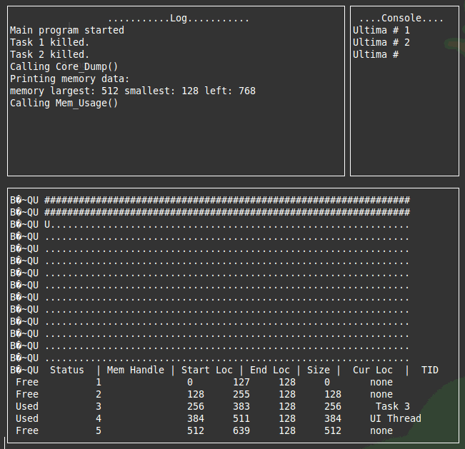

This core dump is after coalesce is gone and it shows that the freed memory is nor converted back to blank (…s).
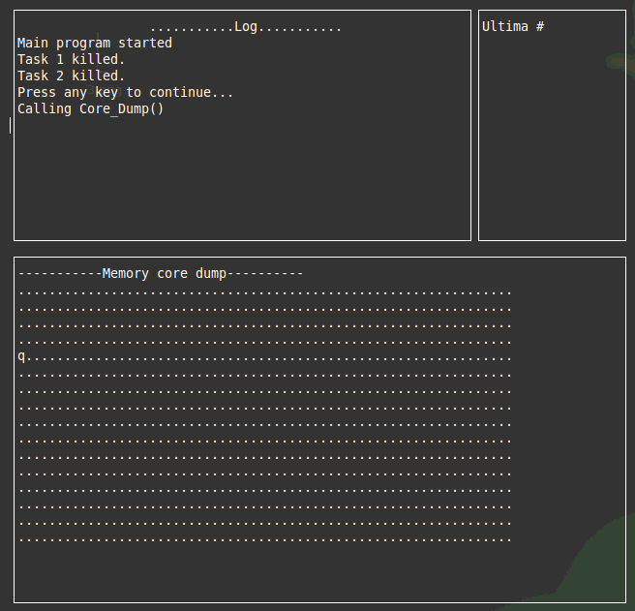

Phase 4:

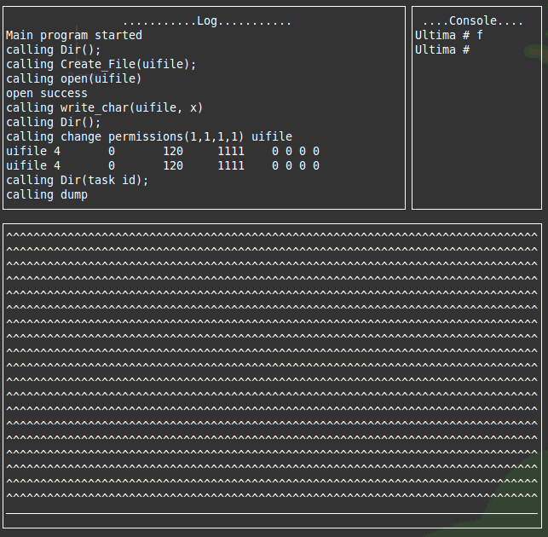

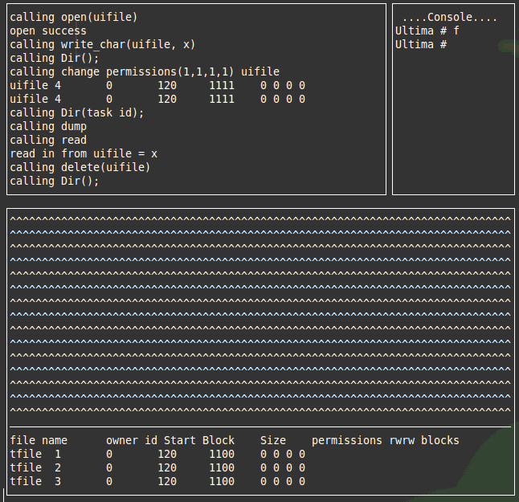

Overall Dump window
